HILLY FIELDS FOOTBALL CLUB
SEASON 24: 1990-91
Beckenham League Veterans Cup
P W D L F A
Old Pastonians 1 0 0 1 1 4
Friendly
Puiu Hesinki Vets 1 1 0 0 4 2
TOTAL 2 1 0 1 5 6

GREENWICH 7-A-SIDE
P W D L F A
17 7 5 5 15 12
Apps Gls Apps Gls
Adrian Bennett 2 0 Mark Burgess 10 1
Mark Cooper 1 0 Damien Cole 6 1
Steve Edwards 1 0 John Felton 10 0
John Felton 2 0 Keith Foster 10 1
Keith Foster 2 0 Chris Green 6 0
Larry Garnham 1 0 Malcolm Hill 4 0
Chris Green 1 1 Phil Hortin 10 0
Ray Griffin 1 0 Mike Lane 6 1
Malcolm Hill 1 0 John Macrea 6 0
Howard Jones 1 0 Steve Morton 6 1
Rob Joseph 1 0 Ralph Stanton 10 2
Steve Morton 1 0 Terry Taber 6 1
Alan Sayers 1 0 Mario Vaz 10 1
Ralph Stanton 1 0 Dave Wright 6 2
Mario Vaz 2 0 Other (Awarded) 4
Dave Wright 1 0
Gus 1 0
Roy 1 4

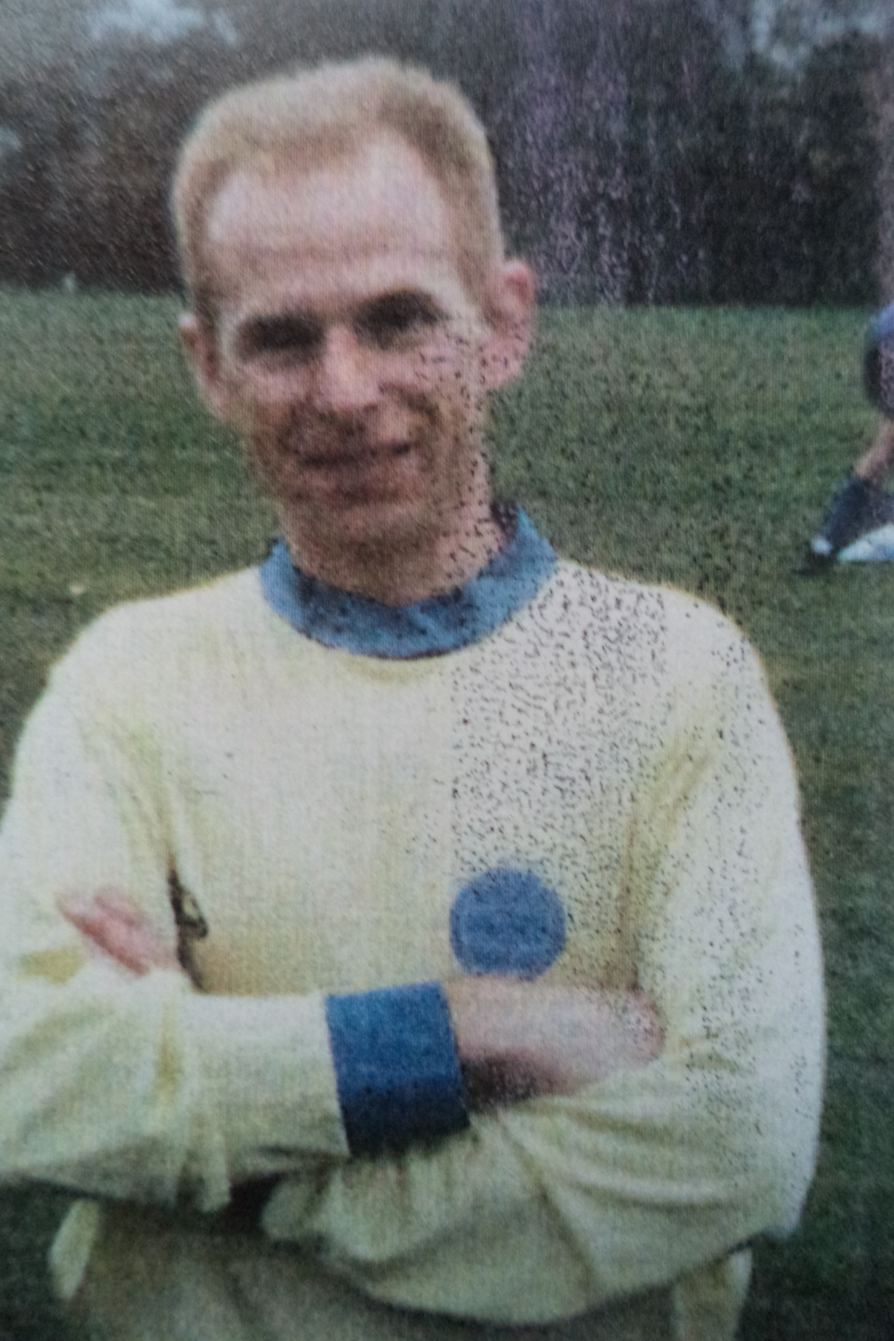
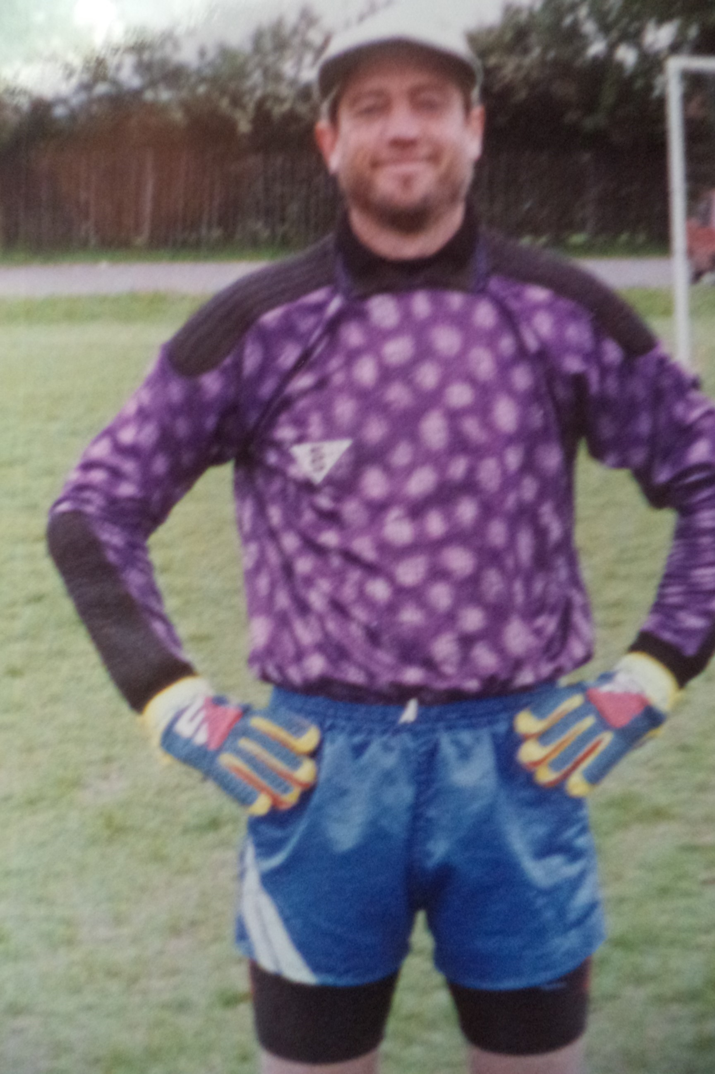
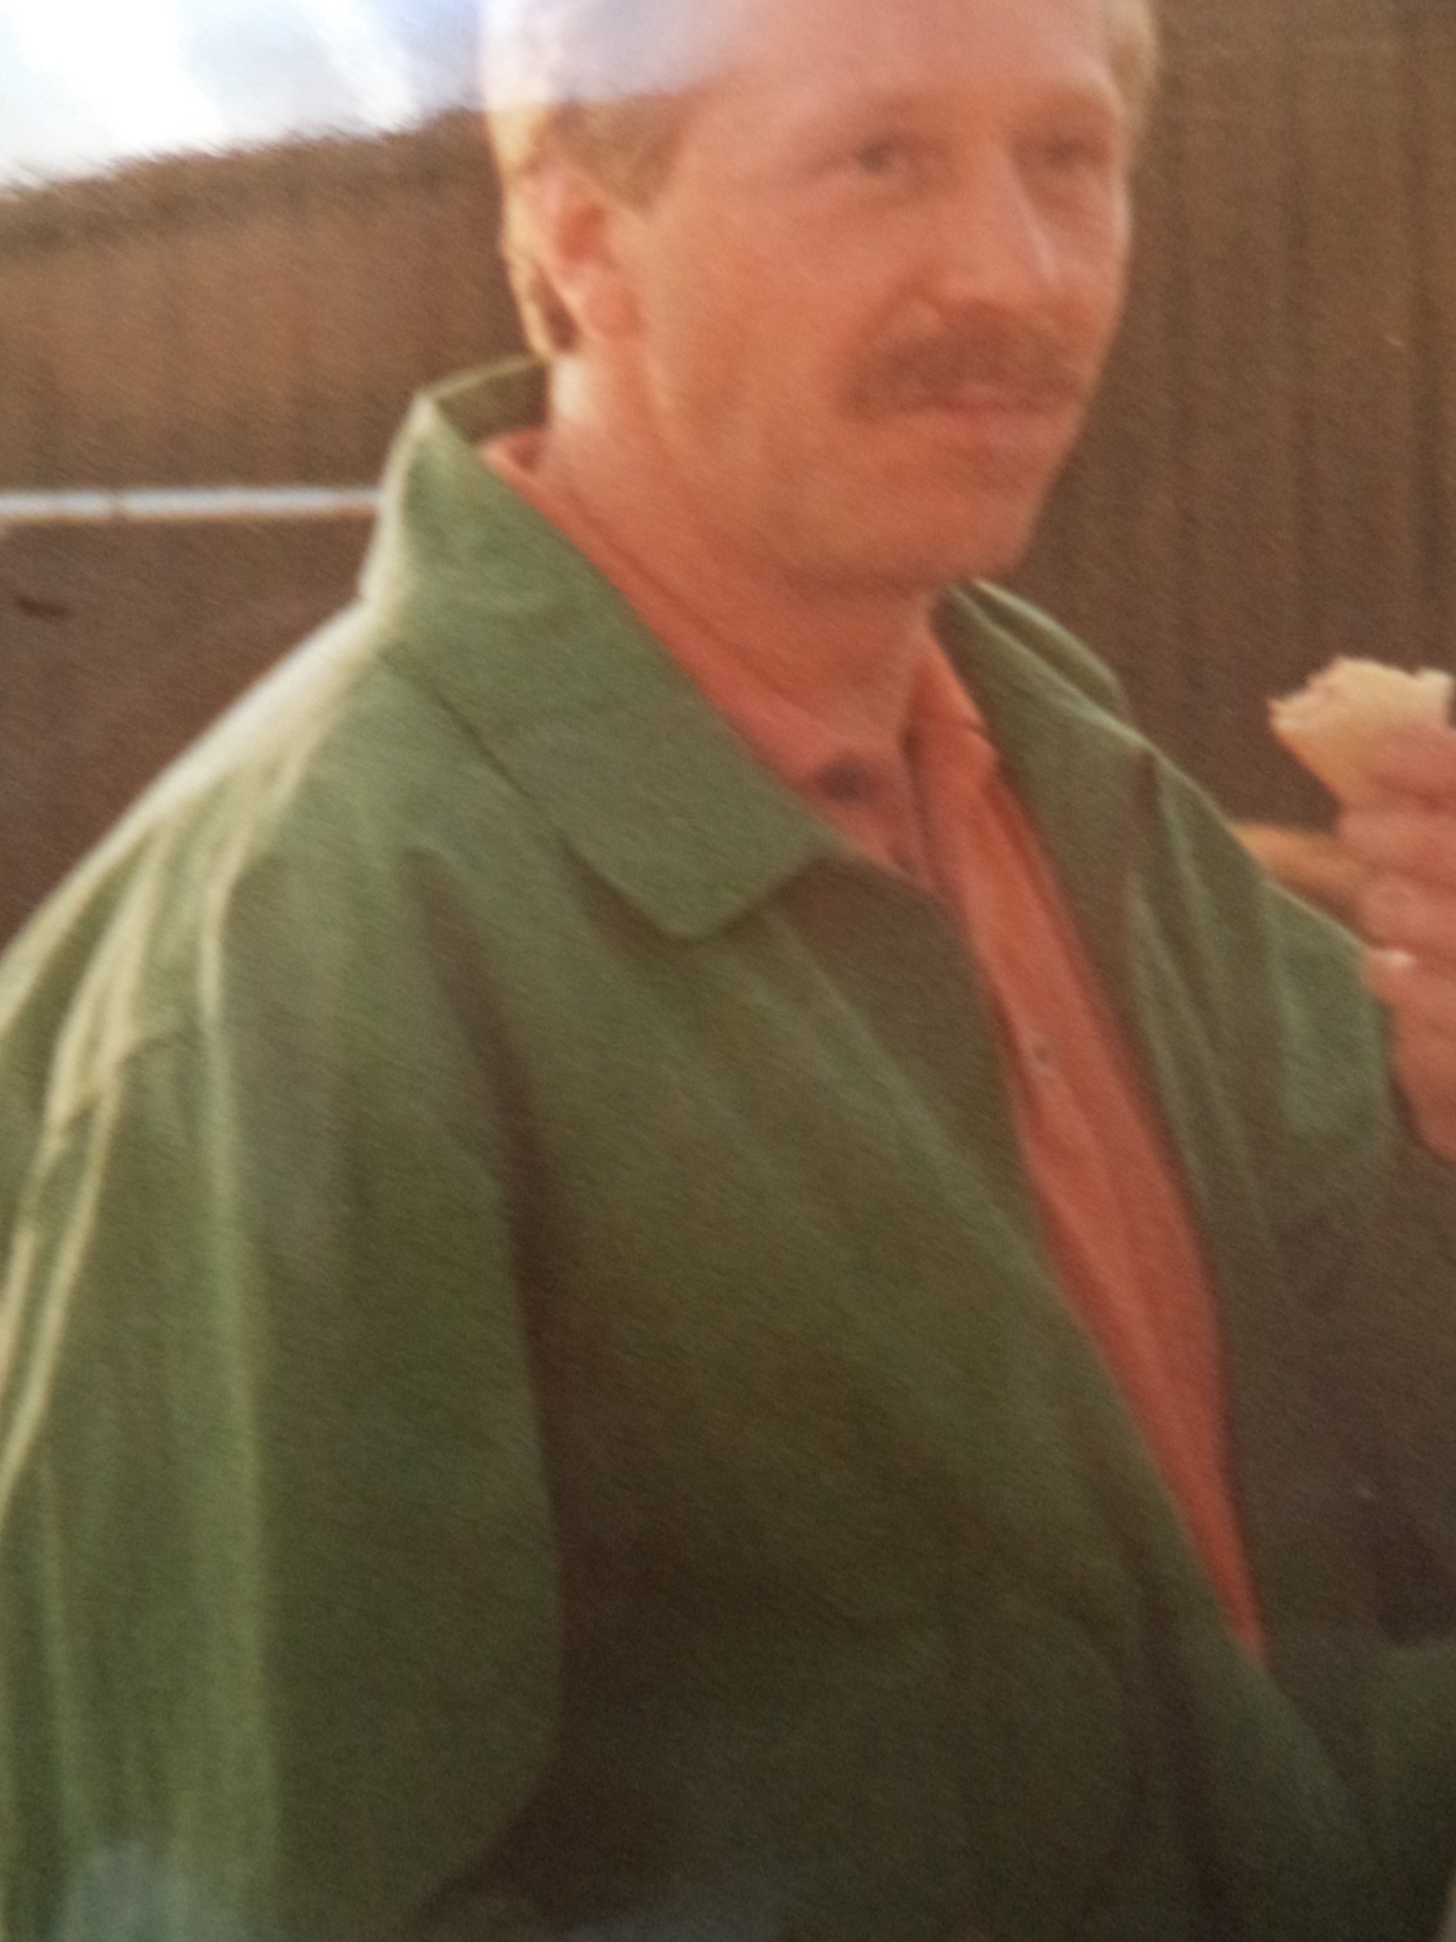
Mark Cooper Phil Hortin Steve Edwards

